**Assignment No:1**

**Programming Fundamentals (Python)**

1. Write two functions which will take required arguments for calculating the Area and Volume of cylinder. Figure 1 is giving for your help.

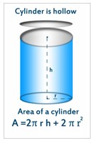

Figure 1 – Calculating the Area and Volume of Cylinder

***[Hint:*** *You will use the following format to get the square on the answer:*

*print("The volume of the cylinder is {0:.{1}f}cm\u00b3".format(volume, decimals))****]***

2. Write two functions which will take required arguments for calculating the Area and Volume of cylinder. Figure 2 is giving for your help.

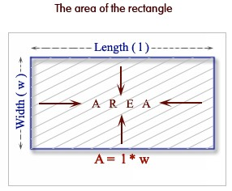

3. Write a function that can calculate the arithmetic sequence of n numbers. The program will generate the nth term of the sequence, whereas the user will enter the first term and the common difference. The program will then ask either to continue or not, if the user will enter yes it will ask the next nth term to calculate. **Example**: you have entered the first term as 3 and common difference 6 you are interesting in 35th term. So it will calculate and generate the answer as 207.

Now it will again ask for you to continue if you agree it will ask next term like 45th or 96th term to

calculate.

𝑎𝑛 = 𝑎1 + (𝑛 − 1)𝑑

4. Write a function which will check either the giving string is Palindrome or not. Palindrome is a string when we reverse the string it will generate the original string. Example CIVIC, MOM, 010,

1001, etc. So if you enter the word which is Palindrome it will say yes your string is Palindrome otherwise it will generate sorry message.

*[Hint: As user may enter upper or lower case, so you may use myString.casefold(). A casefold() will remove all the upper and lower case problems. To generate the reverse of string you can use reversed() function on your string.]*

5. Create a Python application that includes an array holding elements

37, 2, 6,4,90,45,67,21

And sort all the array elements in ascending order.

*[Hint: Your creativity and analysis approach will be checked]*

6. Write multiple functions that can calculate three laws of motions in physics

7. Write a function which will generate your name in reverse order.

8. Write a function which will generate a table of sin(), cos(), tan() with user defined range.